**GOVERNMENT OF TAMILNADU**

**Naan Mudhalvan – Project Based Experiential Learning**

Project Report on

**TABLEAU HR SCORECARD: MEASURING SUCCESS IN TALENT MANAGEMENT**

**Submitted by**

**JEYASATHYA.R (BEC9129707196ECB701440DCBB8932B5)**

**KALEESWARI.G.I (C221C917F10A6DCAFD047030CEB778D5)**

**SUGANYA.G (BBBE150A5E5AF4CB0C64B93BB17210CC)**

**SWARABINDU.E (9F351032B66FC65ACB54C6A80C833E58)**

**THARANI.K (2A85F905A2AB668BEA546D9F17EE0702)**

**(TEAM ID : NM2023TMIDD07182)**

**Under the guidance of**

**Dr. M. GAYATHRI M.Sc., Ph.D**

**Guest Lecturer**

**Department of Mathematics**

GOVERNMENT ARTS COLLEGE FOR WOMEN,

(Affiliated to Mother Teresa Women’s University, Kodaikanal)

Reaccredited with “C” Grade by NAAC

NILAKOTTAI-624 208

**INTRODUCTION**

**Overview**

The Tableau HR Scorecard is a framework designed to measure and evaluate the success of talent management strategies within an organization. It provides a way for HR professionals and business leaders to track and analyze key performance indicators (KPIs) related to workforce planning, recruitment, retention, and development.

The HR Scorecard consists of four main perspectives:

1. Financial Perspective: This perspective focuses on the financial impact of HR initiatives, such as the cost of recruitment, training and development, compensation and benefits, and turnover.

2. Customer Perspective: This perspective measures the satisfaction of internal and external customers of HR services, including employees, managers, and job candidates. It includes KPIs such as employee engagement, manager satisfaction with HR support, and candidate experience.

3. Internal Process Perspective: This perspective assesses the effectiveness and efficiency of HR processes, such as recruiting, onboarding, performance management, and employee development. It includes KPIs such as time to fill vacancies, time to productivity for new hires, and training hours per employee.

4. Learning and Growth Perspective: This perspective evaluates the organization's investment in employee development and its ability to innovate and adapt to changing business needs. It includes KPIs such as employee skills and competencies, employee retention, and the percentage of employees who receive regular training and development

**Purpose**

The business requirement of The Tableau HR Scorecard: Measuring Success in Talent Management is to provide a comprehensive and effective framework for measuring and evaluating the success of talent management strategies within an organization. The primary goal is to enable HR professionals and business leaders to track and analyze key performance indicators (KPIs) related to workforce planning, recruitment, retention, and development. We can do so by creating interactive dashboards and reports, making data-driven decisions and creating forecasting models for future performance. The ultimate goal is to gain insights and improve performance through data visualization technique.

**Problem Definition & Design Thinking**

Analyzing various job natures and creating dashboard, story using tableau.

**Empathy Map**

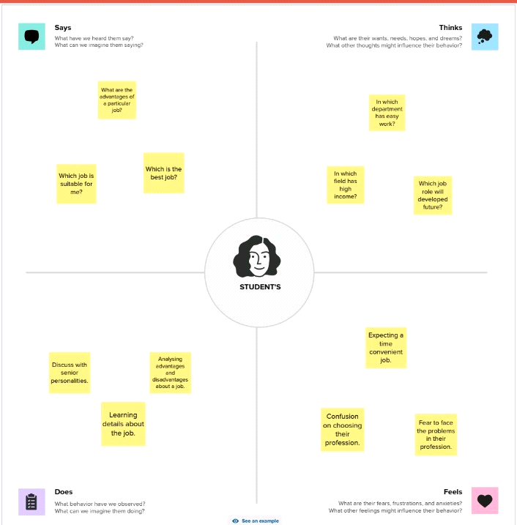

**Ideation & Brainstorming Map**

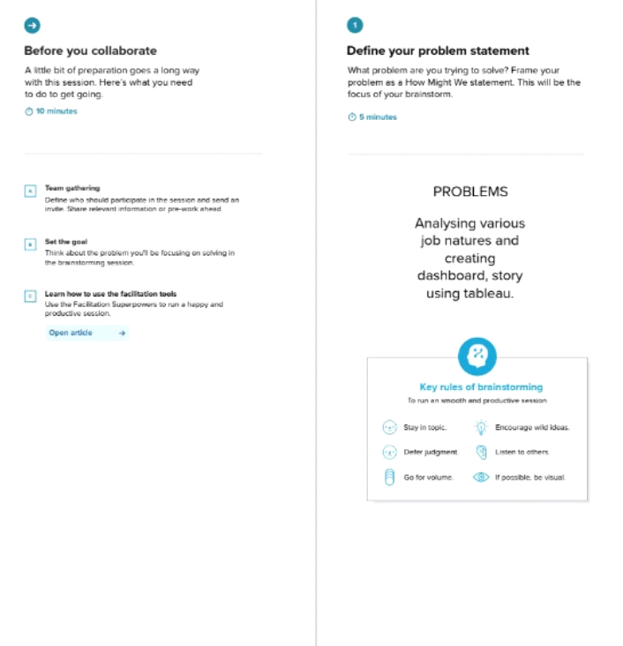

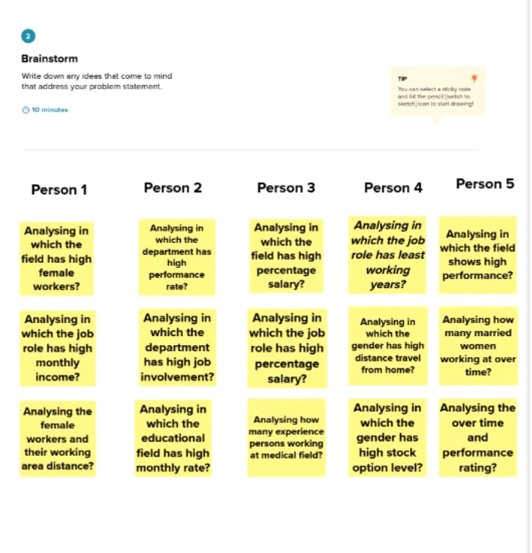

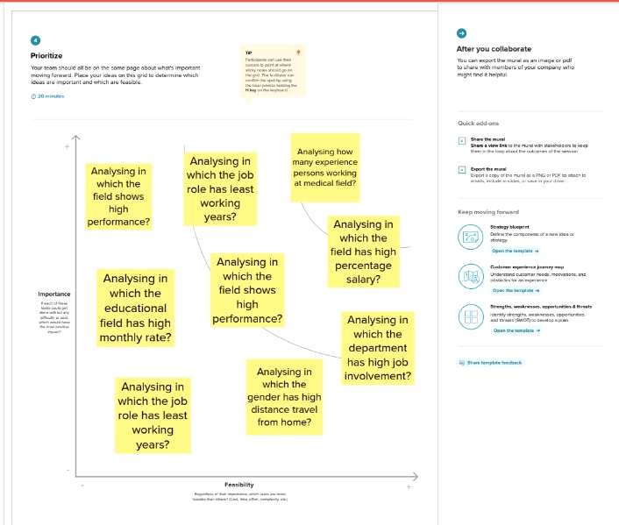

**Results:**

**Activity 1:**

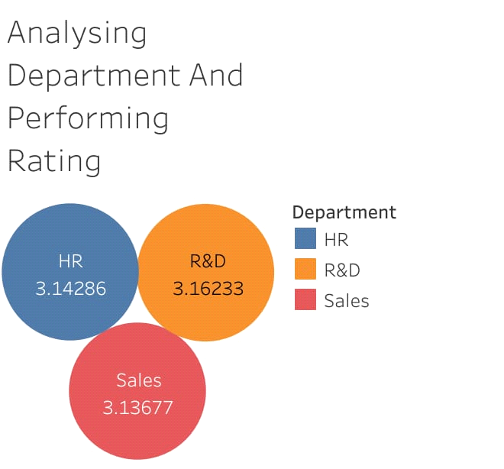

**Activity 2:**

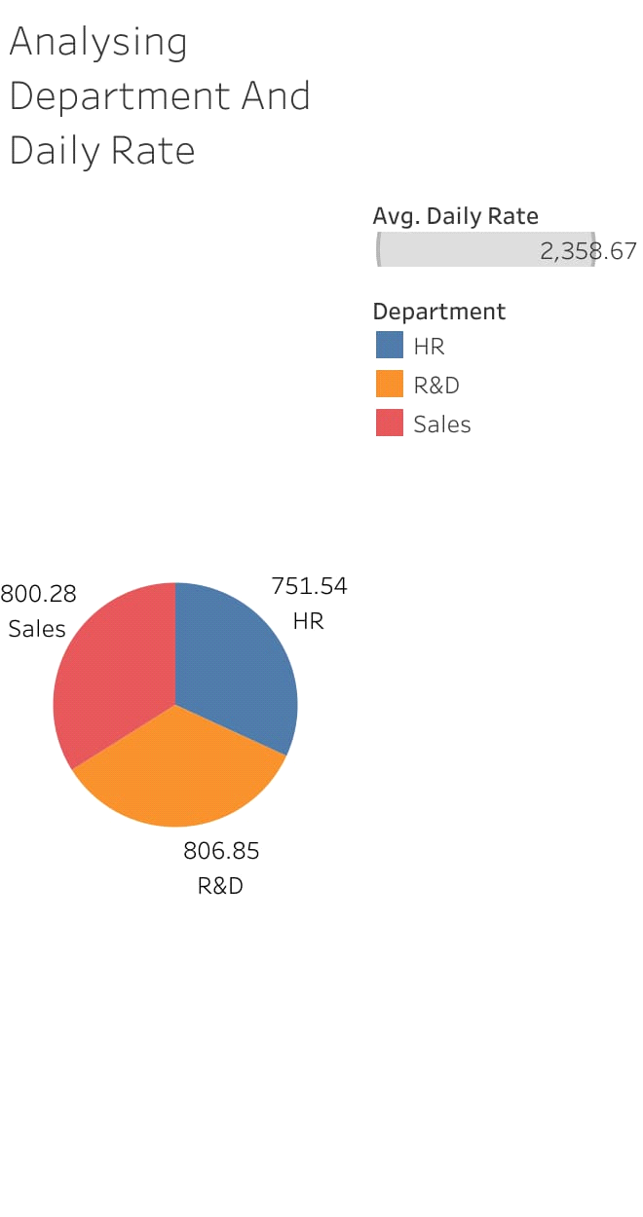

**Activity 3:**

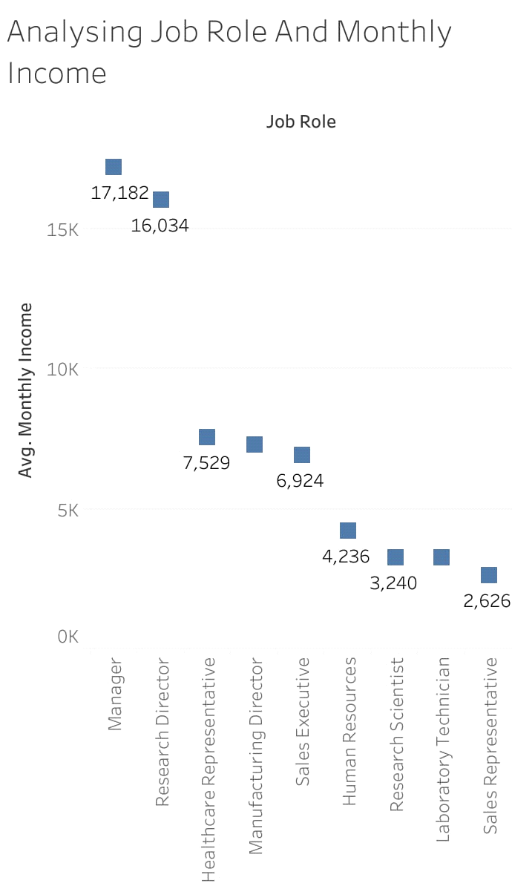

**Activity 4:**

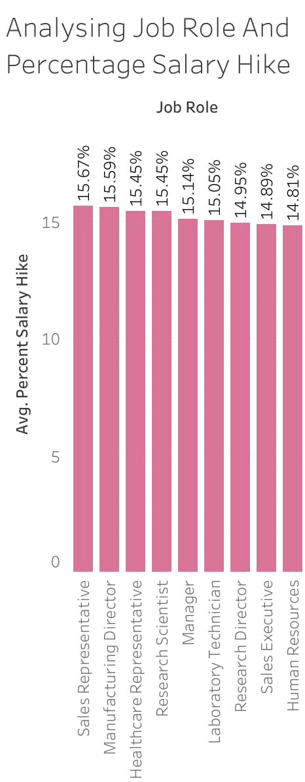

**Activity 5:**

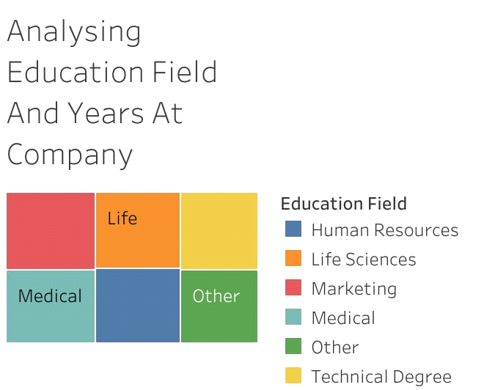

**Activity 6:**

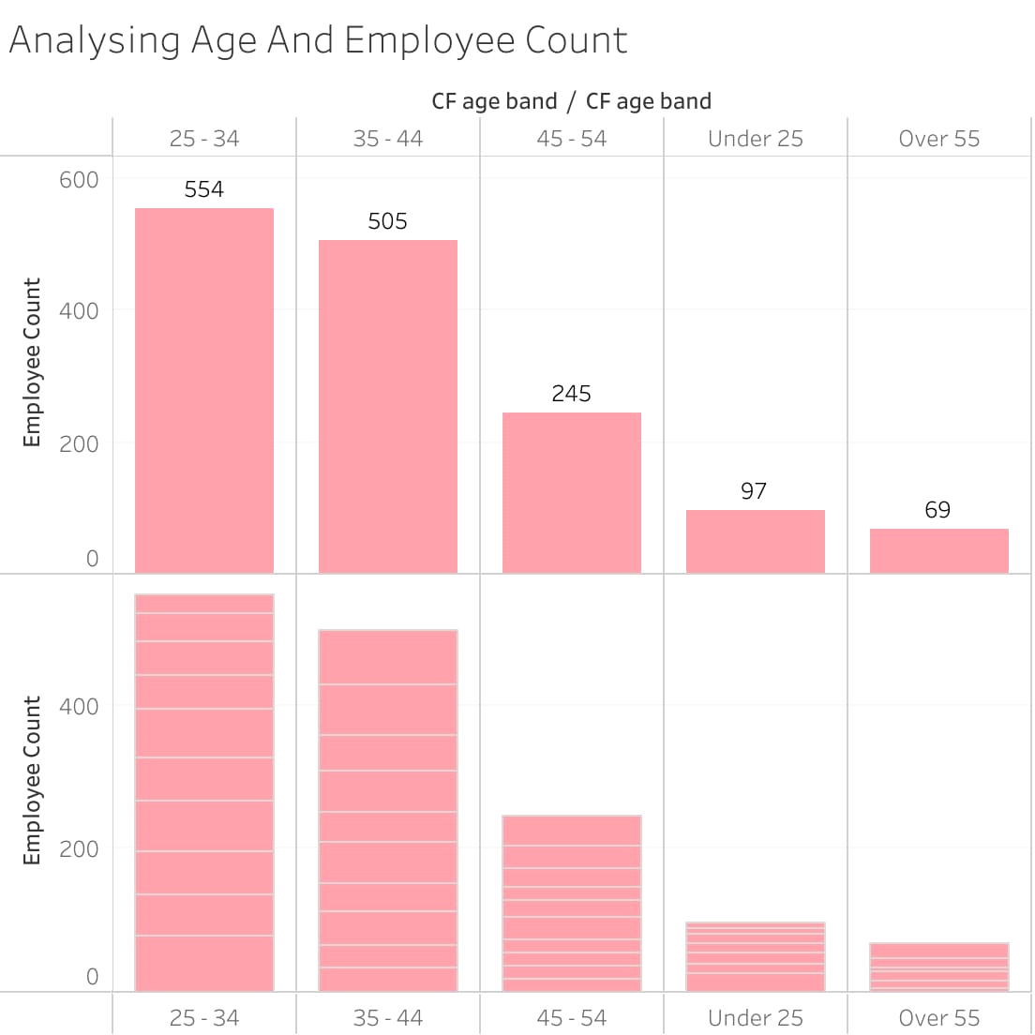

**Activity 7:**

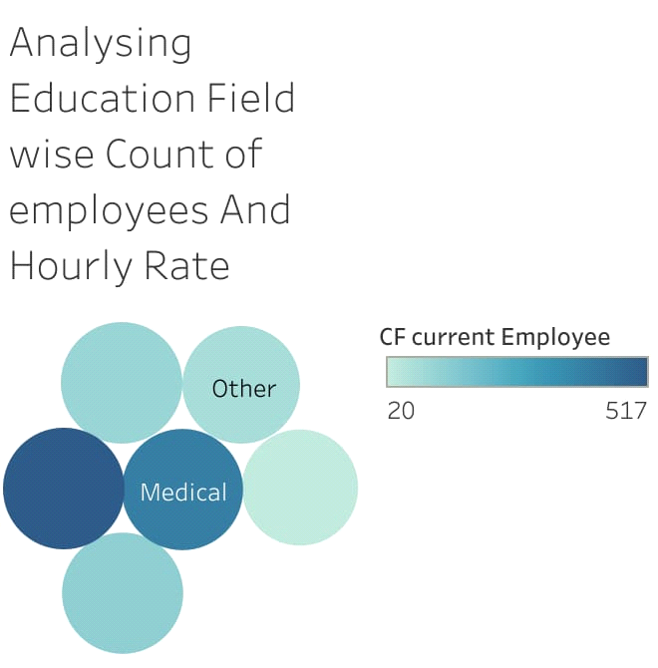

**Activity 8:**

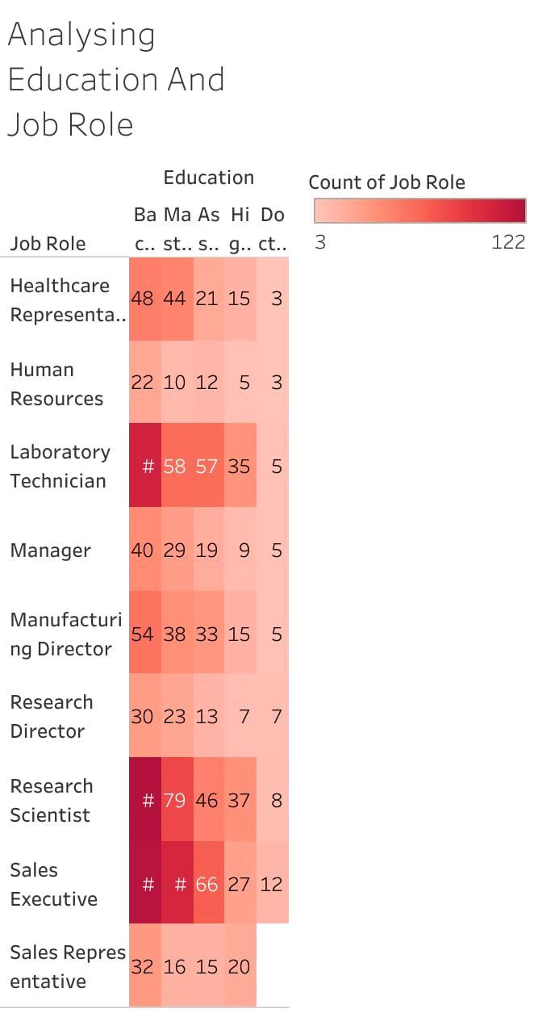

**Activity 9:**

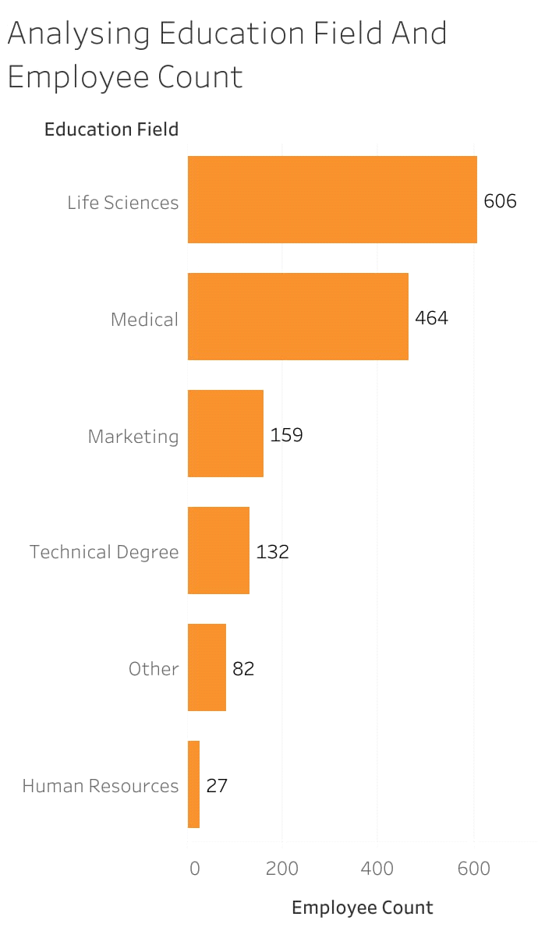

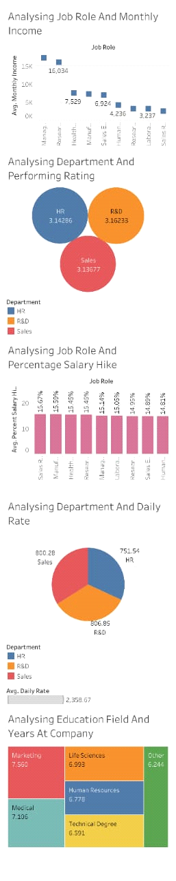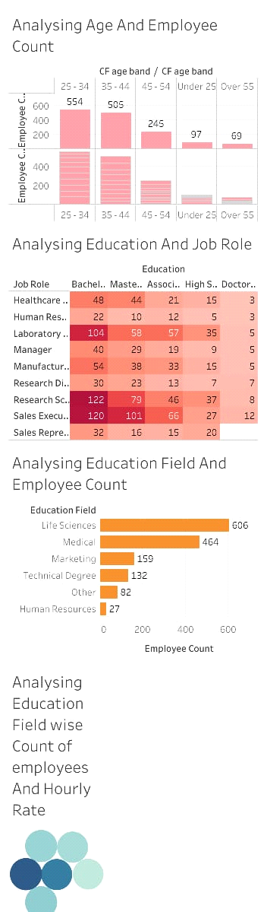

**Story Board**

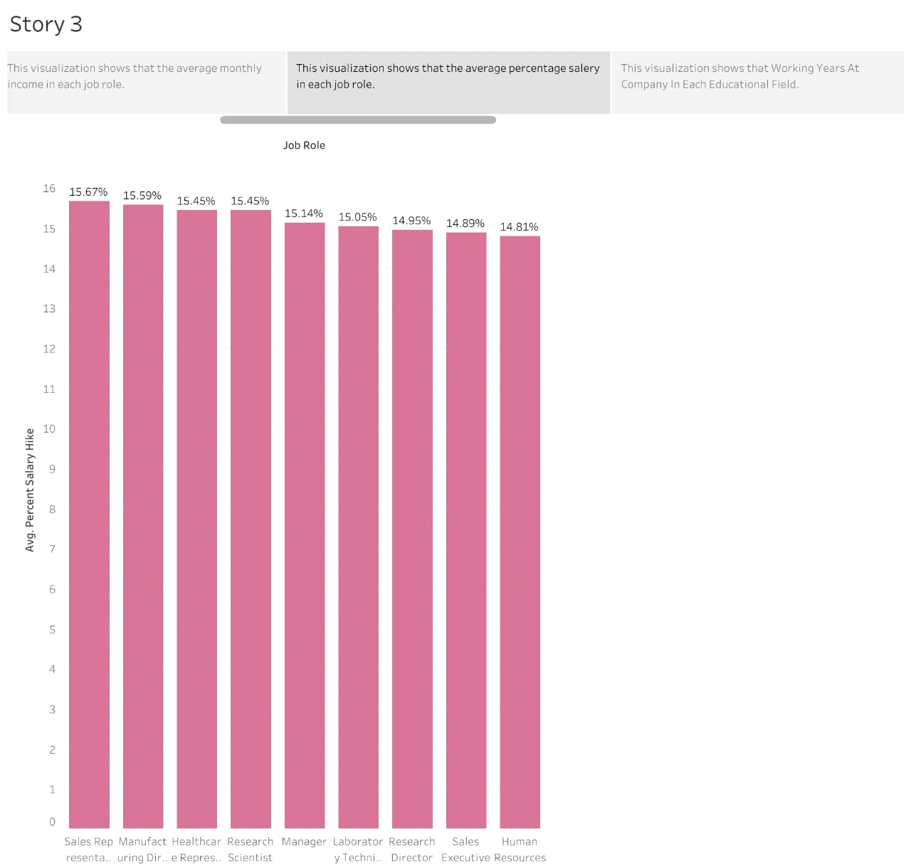

**ADVANTAGES & DISADVANTAGES**

By analyzing various aspects of each job role, department and educational field, a student or a person can choose his career in an effective way.

**Applications:**

**Social Impact:**

1. Improved employee engagement: The HR Scorecard can help organizations measure and improve employee engagement by providing insights into employee satisfaction, retention rates, and other key metrics. This, in turn, can lead to a more engaged and motivated workforce, which can have a positive impact on productivity and overall business performance.

2. Enhanced diversity and inclusion: The HR Scorecard can also help organizations improve their diversity and inclusion efforts by tracking metrics such as the diversity of their workforce, the representation of different groups in leadership positions, and the effectiveness of diversity and inclusion training programs. By identifying areas where they need to improve and taking action to address them, organizations can create a more inclusive work environment that values diversity and promotes equal opportunities.

Business Model/Impact

1. Improved HR performance: By tracking and analyzing key HR metrics, The Tableau HR Scorecard can help organizations identify areas where they need to improve and take proactive steps to address them. This, in turn, can lead to improved HR performance, including increased employee engagement, improved retention rates, and enhanced diversity and inclusion efforts.

2. Enhanced decision-making: The Tableau HR Scorecard can provide HR professionals and business leaders with valuable insights into HR performance, which can help them make informed decisions and take proactive steps to improve business performance. This can include identifying areas where they need to invest in training and development programs, improving recruitment and retention strategies, and optimizing workforce planning and management.

3. Better alignment with business goals: The Tableau HR Scorecard can also help organizations ensure that their HR strategies are aligned with their overall business goals. By tracking key HR metrics and aligning HR initiatives with business objectives, organizations can ensure that their HR strategies are driving business growth and contributing to overall success.

CONCLUSION

In this project, we have created visualizations which describes Department wise performance rate, department wise daily rate, Average monthly income of each job role, percentage of salary hike for each job role, etc. by using tableau.

FUTURE SCOPE

In future, we can extend our analysis of best performance of each job role and risks of each department.